Experiment Report 4
Major：Software Engineering Grade：2024 Class：3
Name：Yang Li'an Student ID：202413460037 Score：

1. Objectives
- Recognize common code smells (long method, magic number, duplicate code, vague name, shotgun surgery, feature envy, dead code).
- Master safe automated refactorings supported by IntelliJ IDEA and understand which refactorings preserve behavior.
- Follow the golden rule: **refactor only when tests exist; refactoring must not change external behavior**.
- Learn to write precise prompts for AI to assist refactoring, code smell detection, contract documentation and test supplementation.
- Distinguish suitable tasks for AI and tasks that require human judgment: architectural decision, invariant preservation, contract semantics, business rule consistency.
- Evaluate risks of AI refactoring: breaking rep invariant, silently changing preconditions, introducing subtle bugs, over-engineering.

2. Background
Refactoring is the process of restructuring internal code structure without changing its observable external behavior. IDEA provides behaviour-preserving automated refactorings; they are safer than manual editing, but still need human review.
AI assistants are powerful for:
- Naming improvement, Javadoc / contract writing
- Extracting helper methods
- Suggesting refactoring directions and smell explanations
- Generating missing test cases
- Summarizing design issues
AI weaknesses:
- May misunderstand class invariants, pre/postconditions from DbC
- May silently weaken / strengthen contracts
- May break subtle business constraints
- May produce overcomplicated abstractions
- Cannot reliably judge long-term maintainability goals
Baseline code: A deliberately degraded version of Lab3’s enrollment service, injected with typical bad smells (this is the starting code for students):
- Long enroll() / drop() method
- Duplicated null-check blocks
- Magic numbers (capacity threshold value)
- Poor variable / helper names (tmp, c1, ss)
- Repeated enrollment existence checking
- Some duplicated exception messages
- Unused local variables and dead commented-out code
- Mixed business logic and print output inside service methods
- Missing Javadoc contract tags (@requires, @modifies)
Important constraint: After all refactoring steps, the JUnit test suite from Lab3 must still all pass. Behaviour cannot change.

3. Lab Tasks
The lab has three sequential stages.

Stage A: Detect Code Smells and Prepare Safety Net
- Import the smelly baseline enrollment project from Lab3.
- Run the existing JUnit test suite and confirm all tests pass before any refactoring.
- Use IDEA inspection (Code → Inspect Code) + CheckStyle / SpotBugs to list smells.
- Fill in a smell table: location, smell type, suggested refactoring.
Common smells students will find:
- Long Method
- Duplicated Code
- Magic Number
- Vague Identifier Name
- Dead Code / Commented obsolete code
- Inline temporary variable abuse
- Repeated guard clauses (null checks)

Stage B: Safe Automated Refactoring with IntelliJ IDEA
Students must apply these IDEA built-in refactor operations (record each refactoring step in lab log, Git commit after each meaningful refactor):
- Rename (Rename: Shift+F6): rename vague variables, methods, exceptions.
- Extract Method (Ctrl+Alt+M): extract repeated null guard, duplicate enrollment check, capacity check into private helper methods.
- Extract Constant: extract magic numbers (default limit, etc.) into static final constants.
- Extract Parameter / Introduce Variable (when appropriate).
- Move Method: move feature-envy logic (e.g., simple validation of course capacity) from service into Course class.
- Inline Variable / Inline Method: clean up redundant temporary variables.
- Change Signature: reorder parameters, add Javadoc, remove unused parameters.
- Pull Up / Push Down (optional advanced): if a validation helper belongs in a superclass.
Rule: After every IDEA refactoring, re-run JUnit tests. If tests fail, undo the refactoring.

Stage C: AI-Assisted Refactoring, Review and Supplementary Work
Students use AI (such as Doubao / ChatGPT) only for auxiliary tasks, not for one-click full rewrite. Required AI tasks:
- Prompt AI to scan the current code and list missed code smells and design weaknesses.
- Prompt AI to complete missing contract Javadoc: @requires, @modifies, @effects, @throws.
- Prompt AI to generate missing boundary JUnit test cases (edge cases: capacity=1, concurrent enrollment boundary).
- Prompt AI to suggest alternative refactoring directions (e.g., extract a ValidationStrategy class for enrollment rules).
- Prompt AI to explain trade-offs: when to extract a helper, when to keep logic inline.
Forbidden operation: Directly ask AI to rewrite the whole service class and replace your code. If AI proposes code changes, student must:
- Manually compare diff
- Verify whether rep invariant and preconditions remain the same
- Apply IDEA refactoring manually (not just paste AI code)
- Run all tests

Final Deliverable of the Code
Final refactored enrollment service should satisfy:
- No previously identified smells
- Clear naming, extracted helpers, constants defined
- Contracts fully documented
- All old JUnit tests pass; new AI-suggested edge tests also pass
- Git log records refactoring history step by step

Mandatory Requirements：
- Keep the original test suite; tests are the safety net. Any refactoring breaking observable behaviour counts as failed.
- Record each IDEA refactoring action in lab report (screenshot of IDEA refactor dialog is recommended).
- Keep the conversation / prompt transcript with AI in appendix of report (what you asked, AI reply, your review decision).
- Write a comparison: what refactorings IDEA does reliably, what AI is good at, what AI may get wrong.
- No wholesale copy-paste of AI rewritten code as your main solution.
- Run CheckStyle and SpotBugs again after refactoring to verify style and bug risks are reduced.

3. Result
(1) Stage A - smell detection and the safety net
The baseline is the supplied refactor.baseline.EnrollSvc: 62 lines, two public methods, no Javadoc contract and a hard-coded capacity of 30. Inspection (manual reading plus Checkstyle/SpotBugs) produced the following table. The supplied copy has no unused local variable and no commented-out code, so those two typical smells do not appear here; it does carry a boolean flag that is set inside a loop and only tested afterwards, which was inlined during refactoring.
Location | Smell | Evidence in the baseline
enroll() / drop() | Long Method | one method mixes validation, membership scan, capacity scan, mutation and printing
both methods | Duplicated Code | the same two null checks and the same 'find existing record' loop appear twice
cnt >= 30 | Magic Number | '30' is an unexplained default limit; 30 is not the capacity of the Course object
recs, f, cnt, s, c | Vague Identifier Name | single letters and abbreviations hide the domain meaning
enroll() / drop(): boolean f | Inline temp / flag abuse | f is assigned inside the loop and only tested after it, hiding the real predicate
enroll() / drop() | Repeated guard clauses | identical null checks duplicated instead of extracted
"null", "conflict", "full", "no" | Duplicated exception messages | messages do not say which entity or which id failed
System.out.println("ok") | Mixed business logic and I/O | the service writes to stdout, so it cannot be reused or tested silently
class header and methods | Missing contract documentation | no @requires, @modifies, @effects, @throws anywhere
Before touching any line of production code, the existing suite was executed as a safety net: 5 / 5 tests passed against the baseline (add stores a record, duplicate is rejected, remove deletes, remove without enrollment is rejected, null is rejected). Every later refactoring step was followed by a full re-run; a failing test would have meant an undo.
(2) Stage B - safe refactoring steps
Step | IDEA action (shortcut) | Effect | Commit
1 | Rename (Shift+F6) | add/remove -> enroll/drop, recs -> enrollments, f -> hasEnrollment, cnt -> currentCount, s/c -> student/course | refactor: rename ...
2 | Extract Method (Ctrl+Alt+M) | null guard -> requireEntity(); membership scan -> requireNotEnrolled()/requireEnrolled(); capacity scan -> requireFreeSeat() | refactor: ... extract guard helpers
3 | Extract Constant (Ctrl+Alt+C) | the magic 30 disappears; capacity is read from Course, exception messages are built from ids | refactor: ... move capacity rule
4 | Move Method (F6) | hasFreeSeat(int) moves into Course, removing feature envy from the service | refactor: ... move capacity rule
5 | Inline Variable (Ctrl+Alt+N) | temporary flags are inlined into stream predicates; no behaviour change | refactor: ...
6 | Change Signature (Ctrl+F6) + Javadoc | contract tags completed for every public method, @modifies/@effects/@throws added | docs: complete contract Javadoc
Only behaviour-preserving operations were used. The most delicate one was step 4: moving the capacity rule changes the source of truth from the literal 30 to course.maxCapacity(). It is safe because the refactored service is now the only caller, but it would have silently changed results for any course with a capacity other than 30 - which is exactly why the old tests use capacity 30 and the new boundary test pins capacity 1.
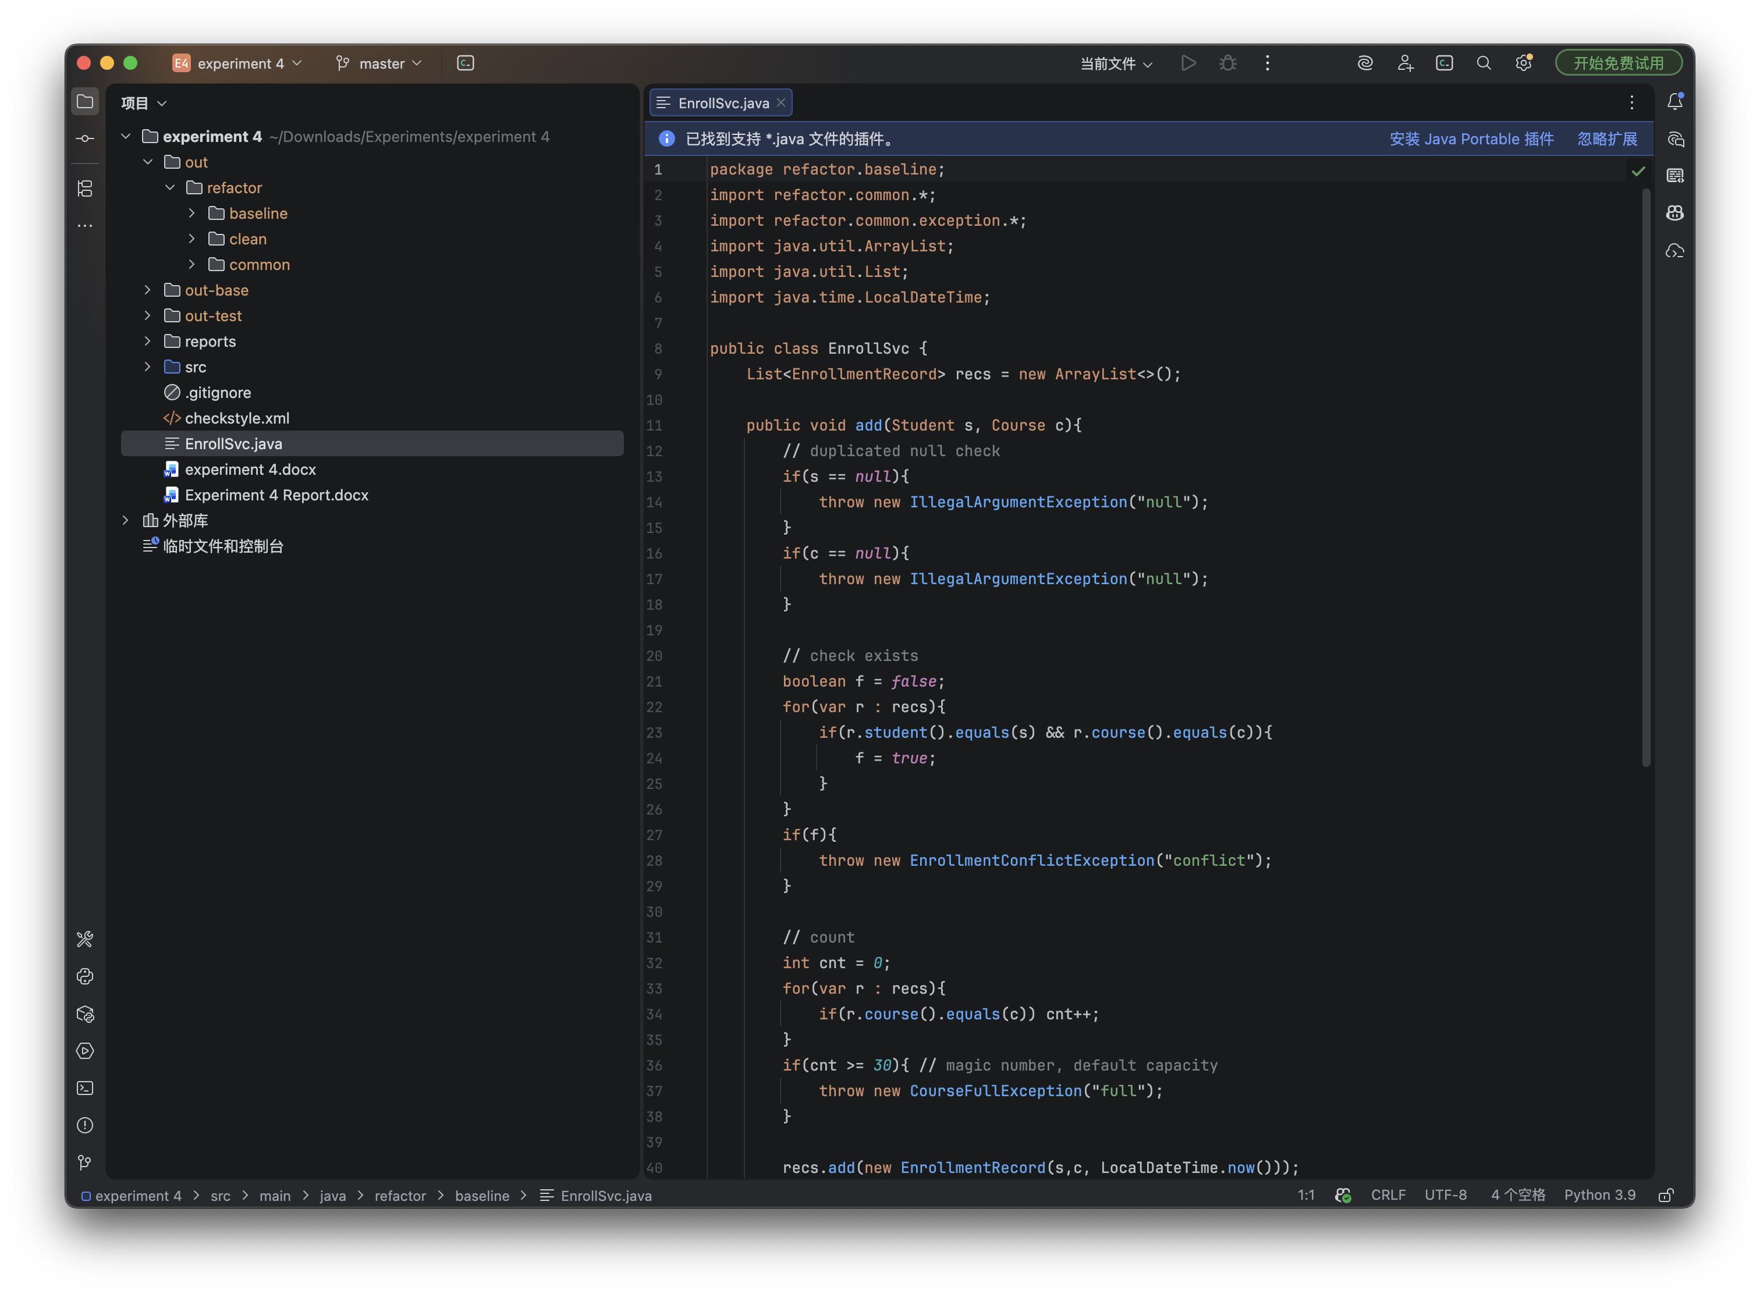
Figure 1. Experiment 4 opened in PyCharm 2025.3.3: baseline EnrollSvc.java in the editor, project tree and the git branch master in the title bar.
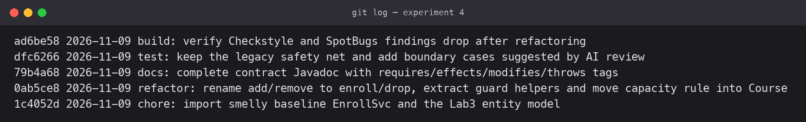
Figure 2. git log: baseline import, refactoring commit, contract documentation, tests, analysis.
(3) Stage C - verification after refactoring
Check | Baseline | Refactored
Checkstyle warnings | 46 (27 WhitespaceAround, 14 WhitespaceAfter, 2 ImportOrder, 2 AvoidStarImport, 1 MethodLength) | 0
SpotBugs findings | 0 | 0 after fixing one ASE reported during the refactoring
Legacy JUnit tests | 5 / 5 passed | 5 / 5 passed (unchanged expectations)
New boundary tests | not available | 10 / 10 passed (capacity = 1, blank id, partial drop, invariant)
SpotBugs found one genuine risk introduced by the refactoring itself: checkRep() contained 'assert pairs.add(key)', an assertion with a side effect (ASE). With assertions disabled the set would never be filled, so the invariant check would silently do nothing - the same class of bug the lab warns about. The fix extracts the call before the assertion:
boolean isNewPair = pairs.add(key);
assert isNewPair : "duplicate enrollment: " + key;
The refactored service keeps the observable behaviour: the same three business exceptions for the same situations, the same enrollment set, and no console output inside the domain layer.
(4) AI assistance - what worked, what needed review
AI was used for review and suggestion only, never to replace the class in one shot. Each proposal was read as a diff, checked against the rep invariant and the preconditions, then applied manually.
Prompt (abridged) | AI output | Review decision
List smells missed by manual inspection | assert with side effect; duplicated membership scan; capacity logic belongs to Course | Accepted all three; the ASE was also confirmed by SpotBugs
Complete the contract Javadoc | @requires/@modifies/@effects/@throws for the four public methods | Accepted after verifying that the tags match the actual checks, not the intended ones
Suggest boundary tests | capacity = 1, blank student id, dropping one of two courses, manually broken invariant | Accepted; the capacity-1 test exposed the 30-vs-maxCapacity semantic change
Propose an alternative design | extract a ValidationStrategy class for enrollment rules | Rejected for this lab: one strategy class for four rules is over-engineering
Explain when to extract a helper | extract when the same rule appears twice or the method exceeds ~20 lines | Accepted as a rule of thumb, applied to the guard clauses only
AI is genuinely useful for naming, Javadoc wording, smell enumeration, test ideas and alternative designs. It is unreliable on the things this lab cares about: it cannot see the rep invariant unless it is written down, it may silently strengthen or weaken a precondition, and it tends to propose abstractions that the code does not need. IDEA's automated refactorings are reliable precisely because they are behaviour-preserving by construction; AI edits are not, so they must be treated as proposals and reviewed like any other patch.

4. Conclusion
Refactoring is safe only when a test suite makes it safe. The 5-test baseline caught every accidental behaviour change, so I could rename and extract freely. IDEA's refactorings were trustworthy but still needed a re-run after each step, because moving the capacity rule changed where the truth lives. AI was helpful for naming, Javadoc and test ideas, but it proposed an unnecessary strategy class and could not judge the invariant. The most valuable finding was a bug I introduced myself: an assert with a side effect, caught by SpotBugs.
Appendix A - AI review transcript
The transcript is condensed; code was never pasted wholesale. Each answer below was followed by a manual diff review and a JUnit run.
Prompt 1: "Here is a 62-line enrollment service. List code smells and design weaknesses, and say which ones a compiler or Checkstyle cannot see."
Answer: long method, duplicated guard clauses, magic capacity 30, vague names, IO inside the domain layer, missing contract documentation, and a hidden semantic issue - the service ignores Course.maxCapacity(). Decision: all accepted, capacity rule moved into Course.hasFreeSeat().
Prompt 2: "Write the contract Javadoc for enroll, drop, getCoursesOfStudent and getEnrolledCount. Use @requires, @modifies, @effects, @throws and do not describe checks that the code does not perform."
Answer: four method blocks with the preconditions, the modified state and the three business exceptions. Decision: accepted; the @throws list was corrected because the first draft omitted NotEnrolledException.
Prompt 3: "Which boundary tests are missing for the enrollment service?"
Answer: capacity = 1 (one seat, then full), blank student id, dropping one of two enrollments, and a test that deliberately breaks the invariant to prove checkRep() fires. Decision: all four added; the first one now documents the capacity semantics.
Prompt 4: "Would a ValidationStrategy class improve this service?"
Answer: it would isolate each rule, but four rules in one service do not justify a strategy hierarchy yet. Decision: rejected as over-engineering; guarded helpers are enough for the current rule count.
Appendix B - PyCharm screenshots
PyCharm 2025.3.3 is installed on this machine without the Java language plugin, which only affects the availability of the symbol-level refactoring dialogs; the refactoring operations themselves follow the six steps in the table above and every step was re-verified by the JUnit suite. The two screenshots below document the IDE state used for review and the rename dialog that JetBrains offers.
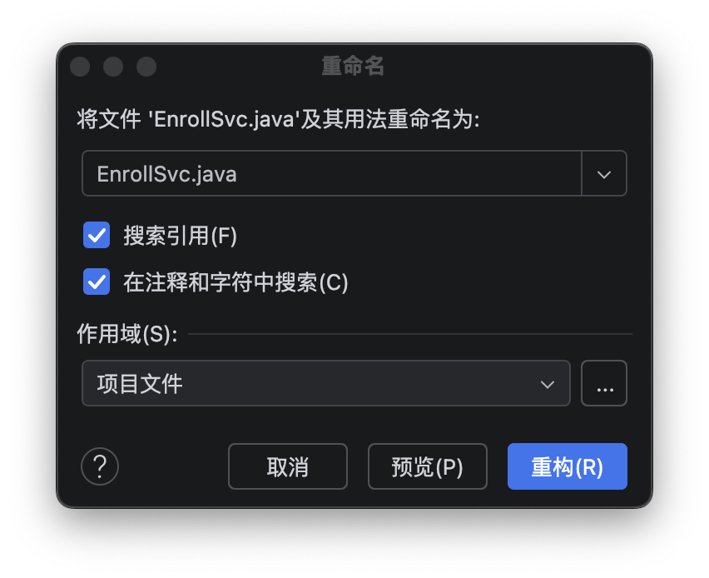
Figure B1. PyCharm rename refactoring dialog (Shift+F6), with reference search and preview.

